Please make sure the update is completed in the game before use：

Like this：

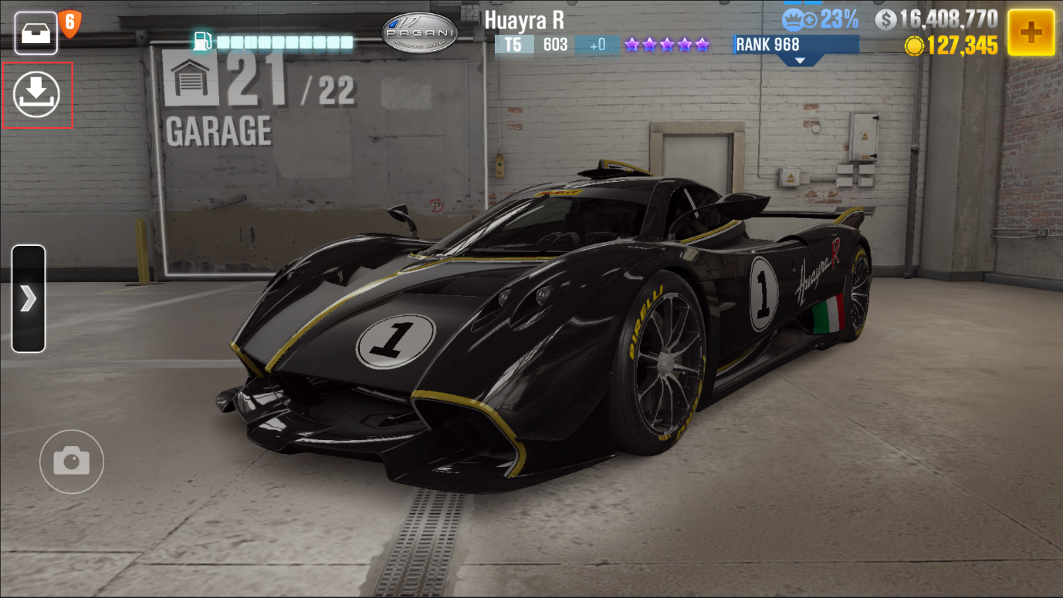



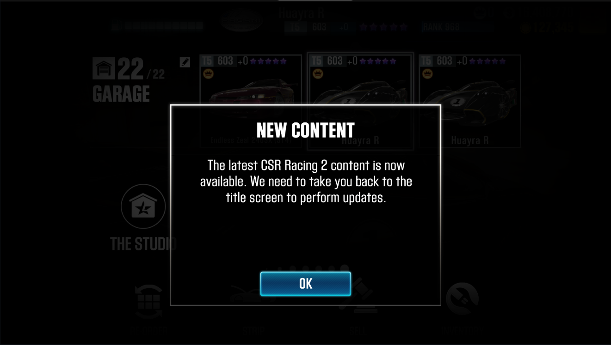

If you stay on the game loading page for a long time, please don't worry, the game background is downloading the *asset_database_3_6_0_Release_OTA* file, keep the loading page for 2-3 minutes, close the game and reopen it, after several attempts, you can enter the game normally.

*By wear87*

*Discord: wear87#4510*